**Explanation CAN code**

* We are using STM32H743VIT6

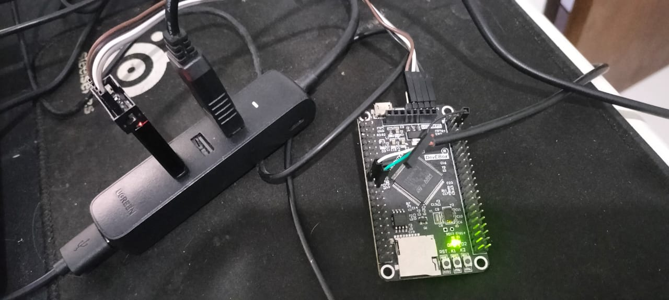

* Using Internal loop-back mode, so we don’t use trans receiver (it cannot connect directly in outside of pin because it is not like UART)

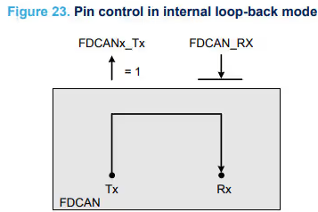

* We are using **HSI** as source clock

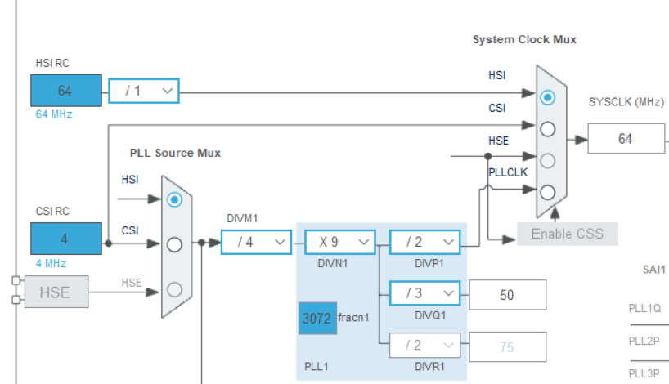

* We are using FDCAN Peripheral Clock in **50 MHz**



* Using online calculator to calculate some timing parameter (<https://kvaser.com/support/calculators/can-fd-bit-timing-calculator/>)

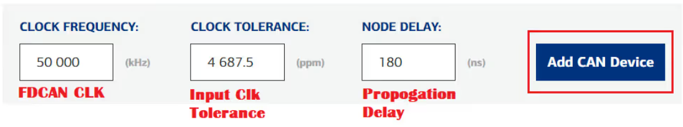

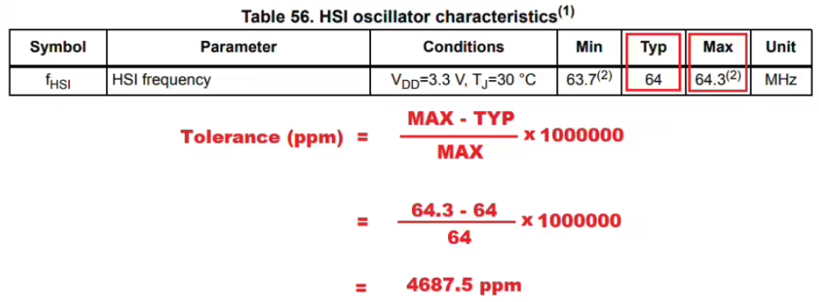

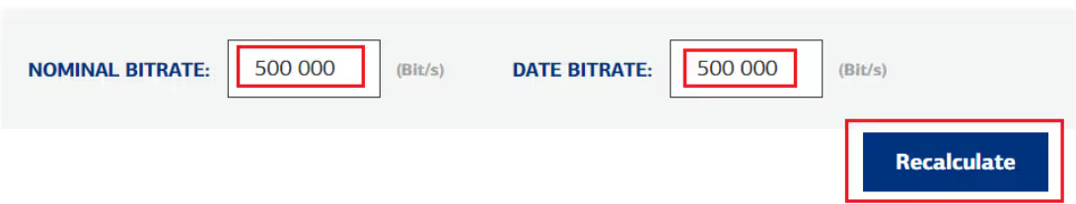

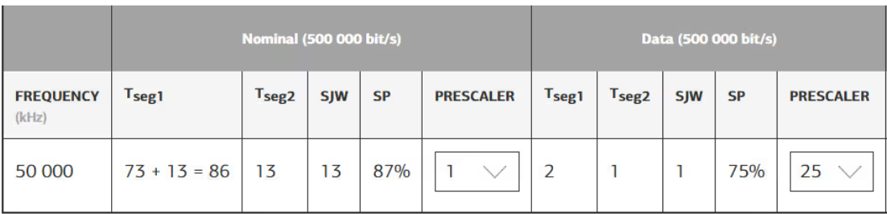

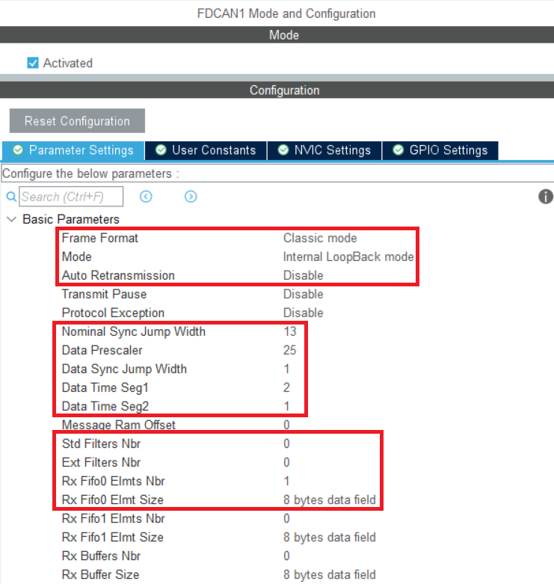 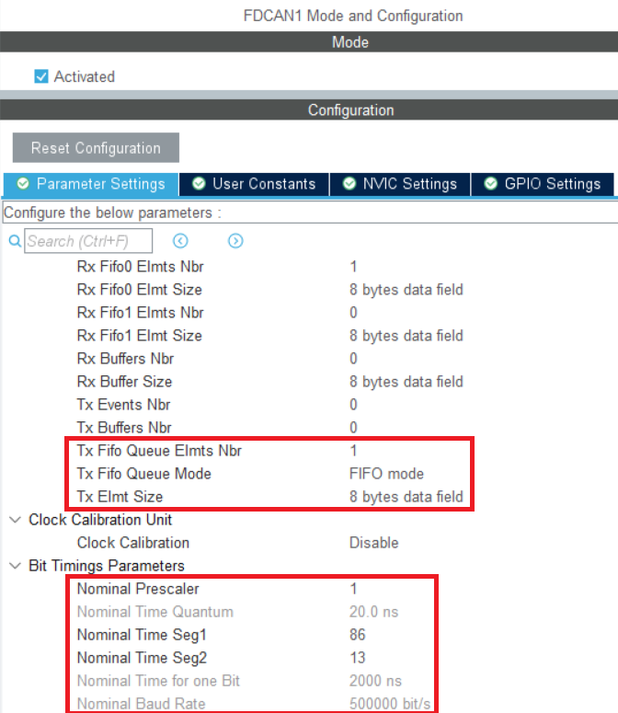

* After we initialize all peripheral hardware, we start CAN transaction

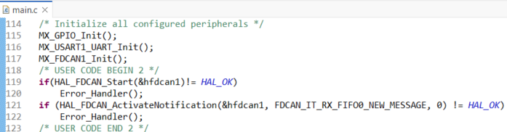

* Using task to send can periodically with free-RTOS (CMSISv1)

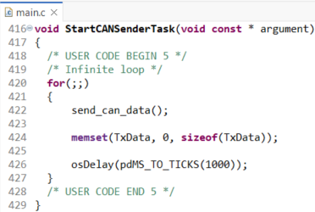

* We are sent 8-byte dummy data frame with increment, that has ID 1 (Standard that have range in 0 - 0x7FF) using classic standard can

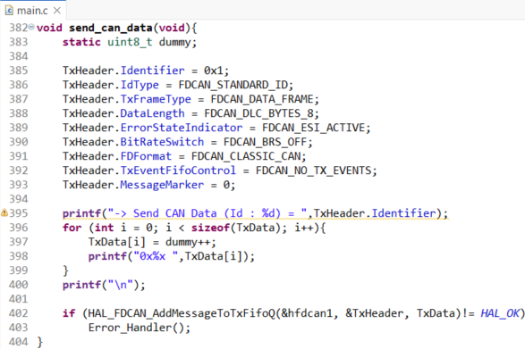

* This function is called in FDCAN1 Interrupt 1, when new message written to Rx FIFO 0 then get it and re-Enable interrupts

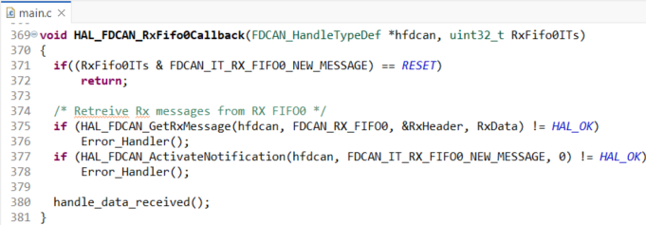

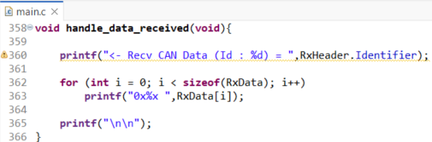

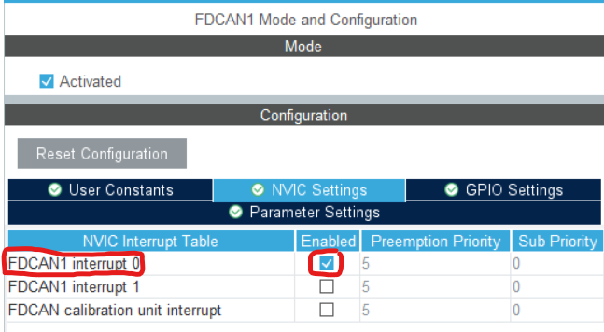

* As u can see data CAN is matched

